Registration Form
PEACE, LOVE, AUTISM Run/Walk
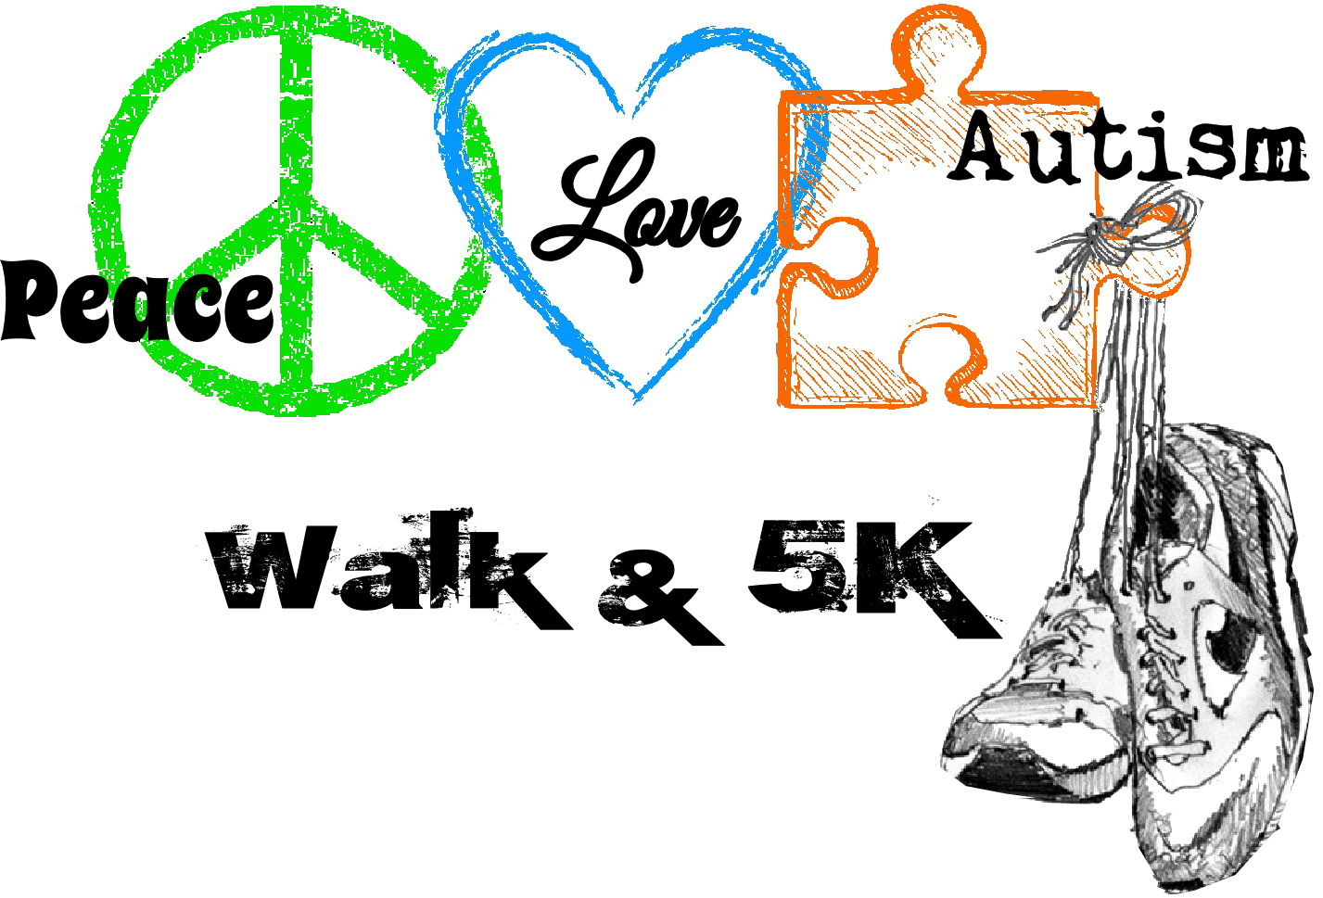
Saturday, September 19th , 2015 –Tipton Park
Run Time: 8:00 am Walk Time: 10:00pm

Adult $20 / Children (12 & under) $10
Run Fees: $25.00
Includes Technical Run / Walk T-shirt

Register as a walker or donor by completing the registration form and mailing it with registration fee(s) to the Autism Society of McLean County by August 28th, 2015. Any registrations received after that date or those registering at the park prior to the event will receive a size large t-shirt while they last.

Collect donations to meet your personal goal and help the Autism Society of McLean County continue supports in the community. Donations are welcome the day of the event. Please turn donation(s) in at the registration table before you walk. Prizes will be given for the highest donors.

Please mail this form and your registration fee(s) to:
Autism Society of McLean County : 2404 East Empire, Suite 231 : Bloomington, IL 61704

Registration forms may be completed at: www.autismmclean.org :: Please Register by September 1st ,2015

I will be: _________ Running ________ Walking
Runner Info: Age ______  Male  Female

Name(s): _________________________________________________________________

Team Name: ______________________________________________________________

Address: _________________________________________________________________

City: _______________________________ State: __________________ Zip: _________

Phone: __________________________ Email: __________________________________

T-Shirt Size (Must be received by September 1st , 2015)
Walk Fees: Adult $20 / Children (12 & under) $10 Run Registration Fees: $25.00

Adult Child
S M L XL 2XL 3XL 4XL S M L

1. | Name: |  | Shirt: |  | Adult |  | Child | Child Age? |  | Size:
2. | Name: |  | Shirt: |  | Adult |  | Child | Child Age? |  | Size:
3. | Name: |  | Shirt: |  | Adult |  | Child | Child Age? |  | Size:
4. | Name: |  | Shirt: |  | Adult |  | Child | Child Age? |  | Size:
5. | Name: |  | Shirt: |  | Adult |  | Child | Child Age? |  | Size:
6. | Name: |  | Shirt: |  | Adult |  | Child | Child Age? |  | Size:

Total Adults _________ Total Children:________
Registration Fee Included: ____________

Waiver: I hereby waive all claims against the Autism Society of McLean County, the sponsors or any individuals for any injury which I may suffer on behalf of myself, my heirs, executors, administrators or assigns. I agree to cooperate with the officials in charge of the event and attest that I am physically fit and prepared for this event.

Signature (Parent or Guardian if under 18)

I give ASMC permission to use photo’s taken at the walk for the purpose of autism awareness and publicity for the Autism Society of McLean County. __________________________________________ _________________
Signature
Date

